# **Get groups that have no owner – Orphan groups (FLOW)**

API Permissions needed: **Group.Read.All**

# The FLOW:

Import the Flow packed and change the values:

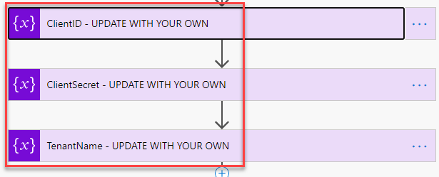

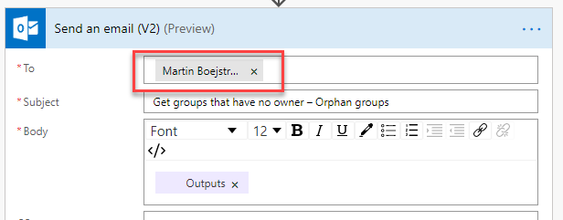

# Sample Result:

